Q4. Write Difference between <head> and <body>.

## Ans. HTML Head

Head is the first part of the HTML document that is used to add additional information to the HTML document.

Head contains meta information, the title of the page, internal style, external stylesheet link, internal javascript, external JavaScript file linking, etc.

The head is not required to be present in the document, but it is recommended to be present.

There should only be one head in an HTML document.

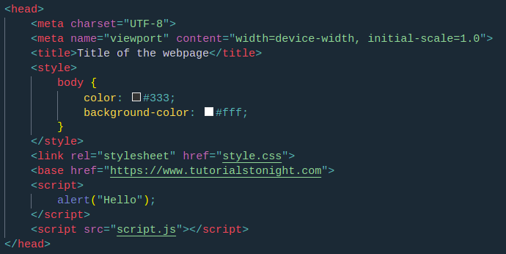

The Head is a block of information that is placed at the top of the document.

The head is the first section of the document and contains information that is shared by all the pages in the document.

Head is not used to add information to the body of the HTML document. This is because the body is the second part of the HTML document and is used to add content to the HTML document.

Example:

<head>

<meta charset="UTF-8">

<meta name="viewport" content="width=device-width, initial-scale=1.0">

<title>Title of the webpage</title>

<style>

body {

color: #333;

background-color: #fff;

}

</style>

<link rel="stylesheet" href="style.css">

<base href="https://www.tutorialstonight.com">

<script>

alert("Hello");

</script>

<script src="script.js"></script>

</head>

HTML

**HTML Body**

Body is the part of HTML that contains the content of the page. The body section is the second section of the HTML document where the first section is head.

Everything that you see, read or hear on a browser lies in the body of HTML, like text, images, GIFs, videos, audios, etc.

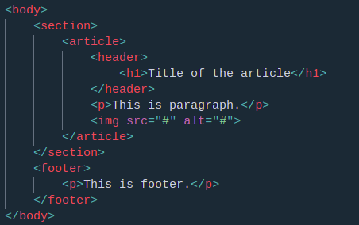

All the HTML elements like <header>, <nav>, <section>, <article>, <h1>, <p>, <img>, <table>, etc all lies in the body section.

Example:

<body>

<header>

<h1>Header</h1>

</header>

<nav>

<ul>

<li>

<a href="http://www.google.com">Google</a>

</li>

<li>

<a href="http://www.facebook.com">Facebook</a>

</li>

</ul>

</nav>

<section>

<h2>Section</h2>

<p>This is a paragraph</p>

</section>

</body>

HTML

**HTML Head vs Body**

HTML head and body are two different sections of HTML document and they are totally different on basis of tag they use, position in the document, elements that lie inside them, their purpose, their compulsion, etc.

|  | **head** | **body** |
| --- | --- | --- |
| **Tag used** | <head> | <body> |
| **Position** | First section | Second section |
| **Purpose** | To add information to the HTML document | To add content to the HTML document |
| **Compulsory** | No (has no effect on content display but should be added) | Yes |
| **Elements inside** | <meta>, <title>, <style>, <link>, <base>, and <script> | All except those used in head, like <h1>, <p>, <img>, etc |

**Example**

The following example is a simple HTML document that uses head and body.

The head section contains meta information, the title of the page, internal style, external stylesheet link, internal javascript, external JavaScript file linking, etc.

The body section contains everything that you see, read or hear on a browser all of it lies in the body of HTML, like text, images, GIFs, videos, audios, etc.

All the HTML elements like <header>, <nav>, <section>, <article>, <h1>, <p>, <img>, <table>, etc all lies in the body section.

The following example is a simple HTML document that uses head and body.

<!DOCTYPE html>

<html>

<head>

<meta charset="UTF-8">

<title>HTML Example</title>

<style>

body {

background-color: #eee;

color: #333;

}

</style>

<link rel="stylesheet" href="style.css">

<script src="script.js"></script>

</head>

<body>

<header>

<h1>Header</h1>

</header>

<nav>

<ul>

<li>First</li>

<li>Second</li>